Day 3: Peripheral Troubleshooting

Learning Objectives
After this session, students will be able to:
- Identify common peripheral problems.
- Understand troubleshooting steps.
- Fix printer, scanner, keyboard, mouse, and webcam issues.
- Apply logical troubleshooting methods in real-life situations.

Theory Session

What is Peripheral Troubleshooting?
Peripheral troubleshooting means finding and fixing problems in external devices connected to a computer.
Examples:
- Printer not printing
- Webcam not detected
- Keyboard not typing
- Mouse not working
- Scanner not scanning

Basic Troubleshooting Flow
Identify Problem
↓
Check Connections
↓
Check Power Supply
↓
Check Drivers
↓
Restart Device
↓
Test Device
↓
Replace Hardware if Needed

Common Peripheral Issues and Solutions

1. Printer Not Printing

Possible Causes
- Printer is OFF
- USB cable disconnected
- No paper
- Paper jam
- Driver missing
- Printer Offline

Solutions
✔ Check power cable
✔ Check USB/Wi-Fi connection
✔ Load paper
✔ Remove paper jam
✔ Restart printer
✔ Reinstall printer driver

Printer Components
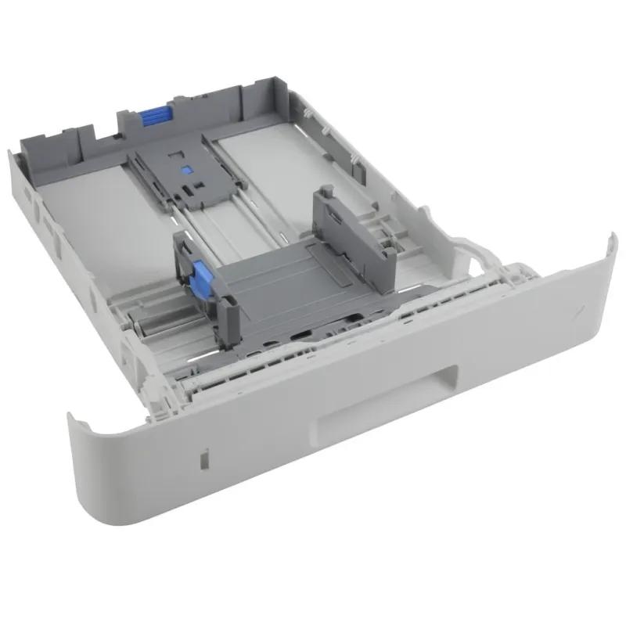
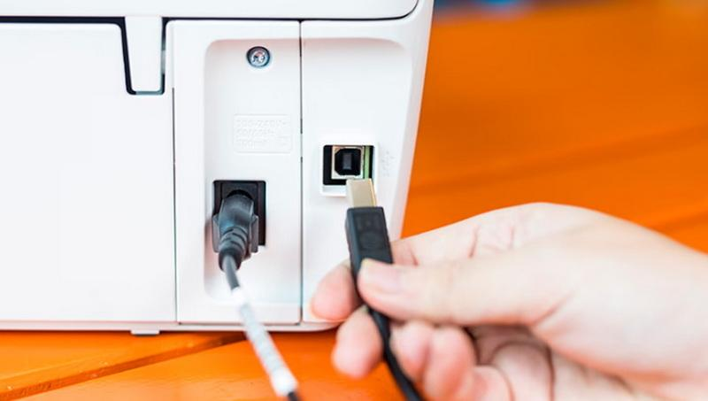
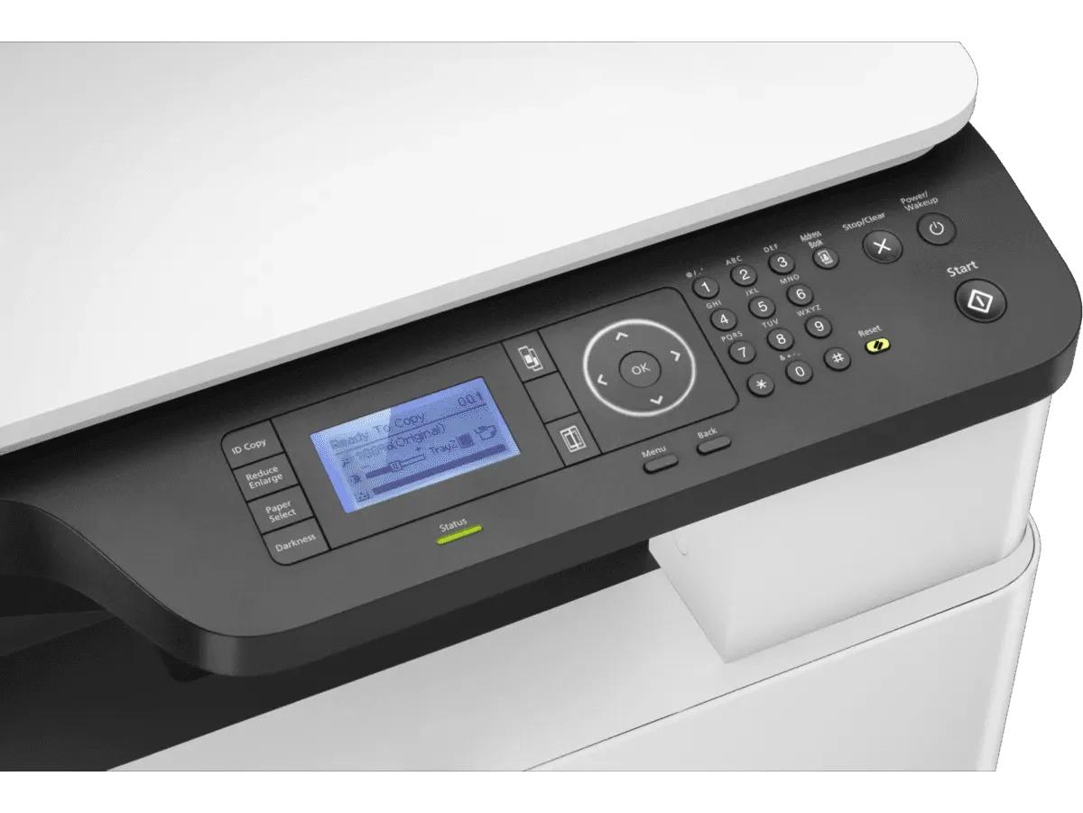
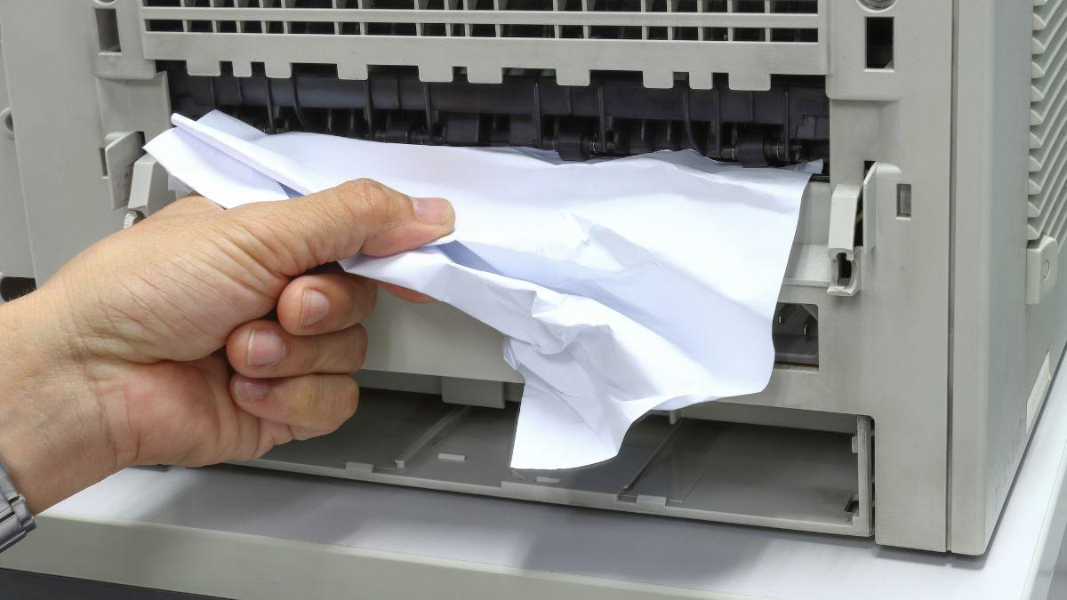

2. Keyboard Not Working

Causes
- Loose USB cable
- Driver issue
- Dust inside keyboard

Solutions
✔ Reconnect keyboard
✔ Try another USB port
✔ Restart computer
✔ Update drivers

3. Mouse Not Working

Causes
- USB problem
- Battery dead (wireless mouse)
- Surface issue

Solutions
✔ Change batteries
✔ Use mouse pad
✔ Try another USB port

4. Webcam Not Working

Causes
- Driver missing
- Camera blocked by privacy settings
- USB issue

Solutions
✔ Check camera permissions
✔ Reconnect webcam
✔ Update driver
✔ Test in Camera Application

Webcam Examples
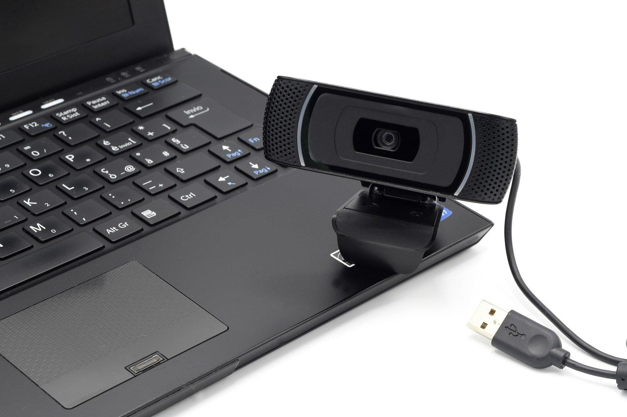
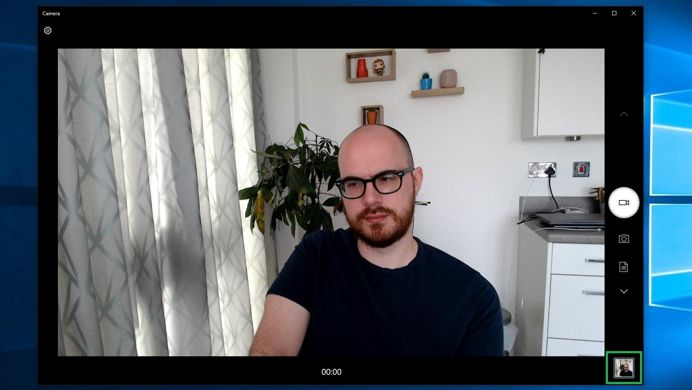
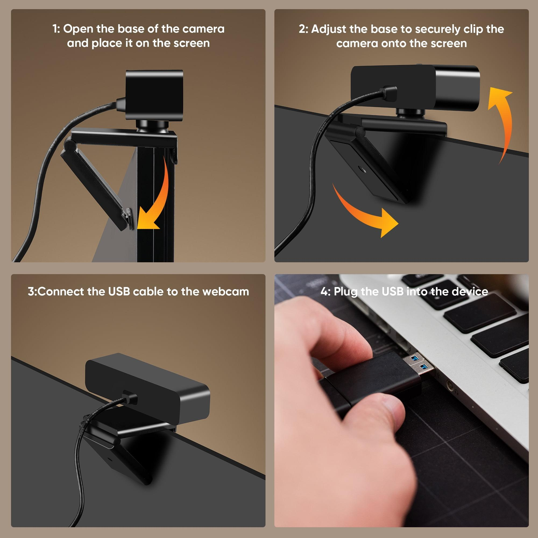
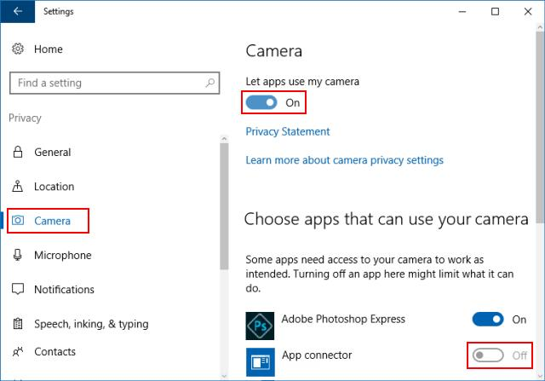
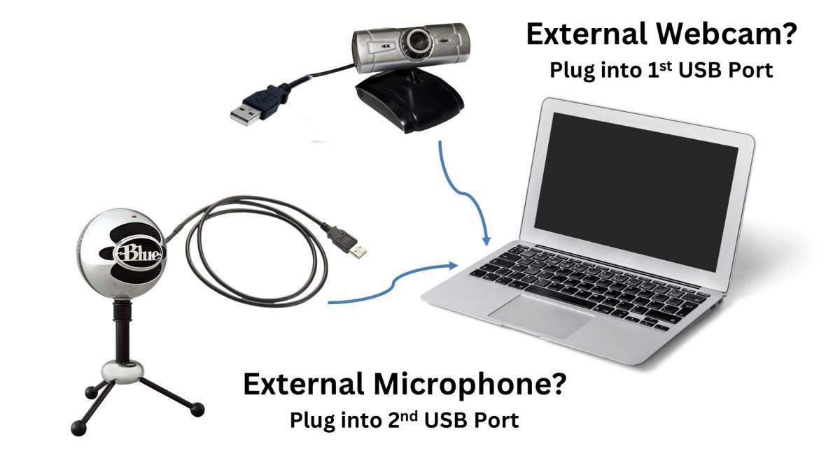
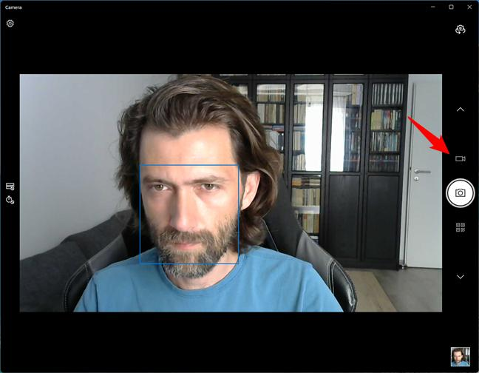

5. Scanner Not Working

Causes
- Driver missing
- USB disconnected
- Scanner software problem

Solutions
✔ Check cable
✔ Restart scanner
✔ Reinstall software
✔ Test with Windows Scan App

Real-Life Troubleshooting Tips

Rule 1
Always check physical connections first.

Rule 2
Restart device before making major changes.

Rule 3
Check Device Manager for errors.

Rule 4
Test device on another computer.

Rule 5
Never assume hardware is faulty immediately.

Practical Session

Practical 1: Troubleshoot Non-Working Printer

Scenario
Student reports:
"Printer is connected but not printing."

Step 1
Press:
Win + R
Type:
control printers
Press Enter.

Step 2
Check printer status.
Possible status:
Offline
Paused
Ready
Error

Step 3
Right-click Printer
Select:
See What's Printing
Remove stuck jobs:
Cancel All Documents

Step 4
Check USB Cable
Disconnect and reconnect.

Step 5
Restart Printer
Turn OFF
Wait 10 seconds
Turn ON

Step 6
Print Test Page
Printer Properties
→ Print Test Page

Step 7
Check Device Manager
Win + X
→ Device Manager
Look for:
Yellow Warning Symbol

Expected Result
Printer should successfully print test page.

Day 4: Connecting and Testing Peripherals

Learning Objectives
Students will:
- Connect peripherals properly.
- Install required drivers.
- Test devices.
- Solve connectivity issues.

Theory

Steps to Connect Any Peripheral

Step 1
Connect device physically.

Step 2
Power ON device.

Step 3
Install drivers if required.

Step 4
Verify detection in Windows.

Step 5
Test functionality.

Common Peripheral Connections
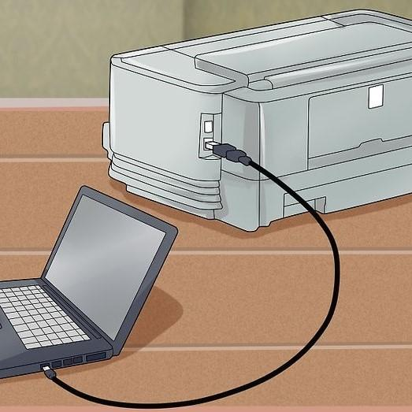
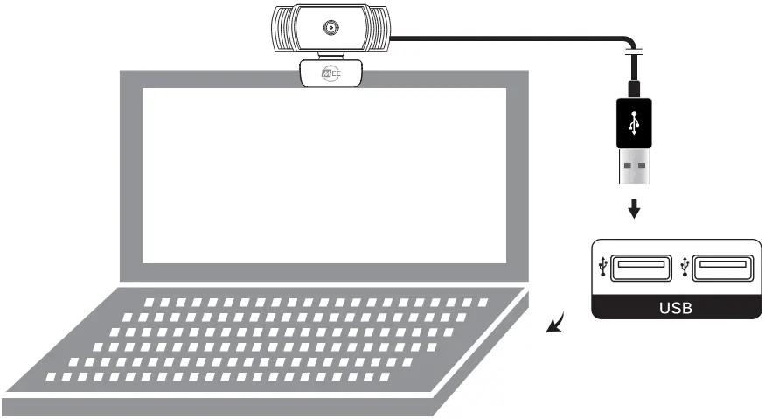
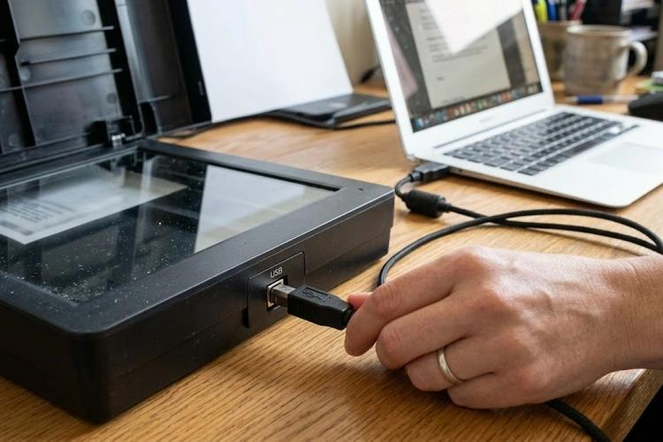
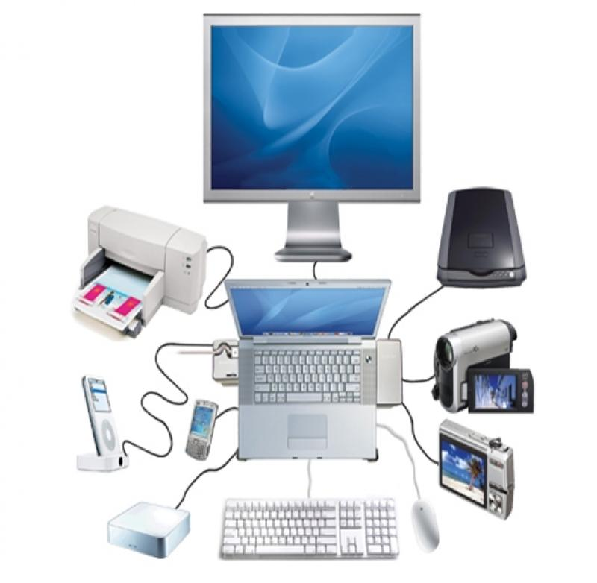
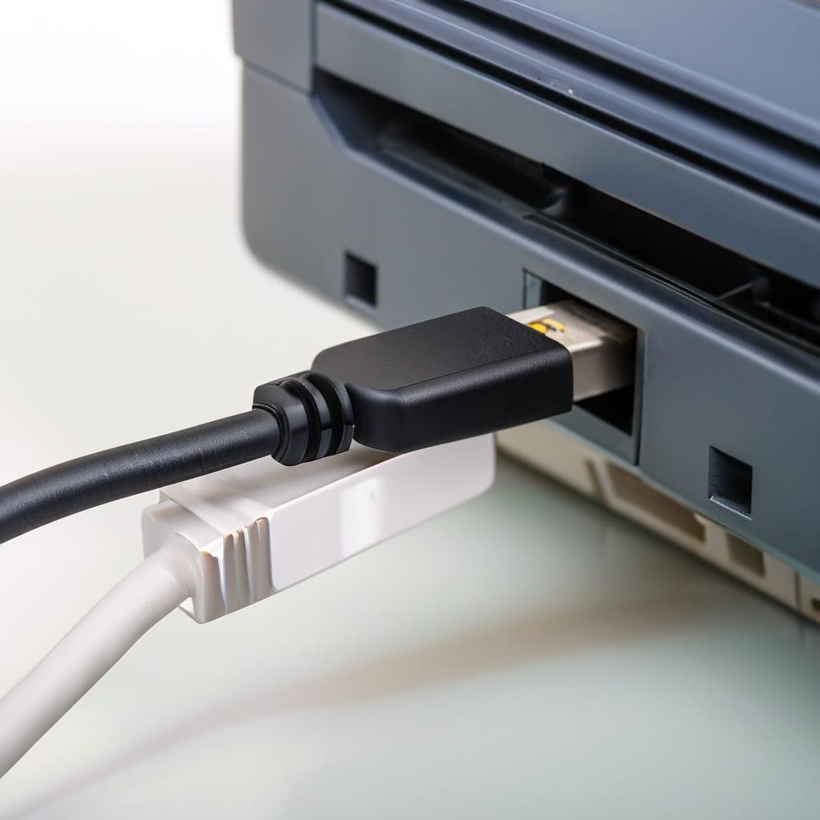
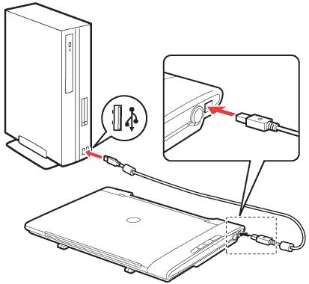

Practical Session

Practical 1: Setup and Test Printer

Tasks
- Connect printer USB cable.
- Power ON printer.
- Install printer driver.
- Open:
Control Panel
→ Devices and Printers
- Print Test Page.

Success Criteria
Printer prints test page successfully.

Practical 2: Setup and Test Webcam

Tasks
Connect webcam.
Open:
Camera App
Verify live video.

Success Criteria
Video feed visible.

Practical 3: Setup and Test Scanner

Tasks
Connect scanner.
Open:
Windows Scan
Scan one document.
Save as PDF.

Success Criteria
Document scanned successfully.

Real-Time Lab Tasks (Interesting Activities)

Task 1: Mystery Printer Problem
Instructor secretly:
- Disconnect printer USB cable
OR
- Set printer Offline
Students must find and fix issue.

Task 2: Webcam Detective
Instructor:
- Disable webcam from Device Manager
Students must:
- Find issue
- Enable device
- Test camera

Task 3: Driver Missing Challenge
Uninstall a webcam/printer driver.
Students must:
- Open Device Manager
- Identify unknown device
- Reinstall driver

Task 4: Wrong USB Port Challenge
Connect peripheral to faulty USB port.
Students must:
- Diagnose issue
- Test another port
- Verify working condition

Task 5: IT Support Engineer Simulation
Scenario:
Client says printer is not printing and webcam is not detected.
Students must create a troubleshooting report:
Check | Status
Power Supply | OK
Cable Connection | OK
Driver Installed | OK
Device Detected | OK
Test Successful | YES

Bonus Practical (Students Love This)

View All Connected Devices
Open CMD:
driverquery
Shows installed drivers.

Check USB Devices
Open PowerShell:
Get-PnpDevice
Shows all connected hardware.

Open Device Manager Quickly
devmgmt.msc

Print Queue Shortcut
control printers

=====================================================================
1. Matrix Screen Trick 😎
Open CMD and type:
color 0A
tree C:\
Or save this in Notepad:
@echo off
color 0A
:a
echo %random%%random%%random%%random%
goto a
Save as:
matrix.bat
Students will see a screen similar to the one in the Matrix movie.

2. Fake Virus Prank
Write this in Notepad:
@echo off
msg * Virus Detected!
msg * System Scan Started!
msg * Just Kidding :)
Save as:
prank.bat
Note: For educational purposes only.

3. Personal Computer Information
In CMD:
systeminfo
Challenge:
- How much RAM does the computer have?
- What is the installation date?
- Which Windows version is installed?

4. Wi-Fi Password Reveal
Open CMD as Administrator:
netsh wlan show profiles
Then:
netsh wlan show profile name="WiFi_Name" key=clear
Find:
Key Content
Learning: Understand where stored Wi-Fi passwords are displayed.

5. Hidden God Mode
Create a new folder on the Desktop:
GodMode.{ED7BA470-8E54-465E-825C-99712043E01C}
An instant Windows Control Center will appear.
Students will find it magical 😄

6. Secret Clipboard History
Press:
Win + V
Clipboard History will open.
Challenge: Copy 5 different pieces of text and test it.

7. Emoji Panel
Press:
Win + .
The Windows Emoji Panel will open.
Useful for LinkedIn, Teams, emails, and more.

8. Record Your Screen Without Software
Press:
Win + G
Xbox Game Bar will open.
Challenge: Record your screen for 10 seconds.

9. Shutdown Timer
In CMD:
shutdown -s -t 60
To cancel:
shutdown -a
Learning: Introduction to system administration concepts.

10. Open Websites From CMD
In CMD:
start google.com
Or:
start youtube.com
Students may find this interesting.

11. Create a Folder With a Reserved Name
In CMD:
mkdir \\?\C:\con
Explain the concept of reserved Windows device names:
- CON
- PRN
- AUX
- NUL

12. Generate a Battery Report
On a laptop:
powercfg /batteryreport
A battery report will be generated.
Challenge: Find the battery health information.

13. See Who Is Logged In
In CMD:
query user
Or:
whoami
Learning: Understanding user accounts and logged-in users.

14. Find Open Network Connections
In CMD:
netstat -ano
Challenge: How many active connections are there?

15. Open the Secret Character Map
Run:
charmap
Copy and explore special symbols.
Useful for learning about character sets and symbols.

16. Keyboard Shortcut Race
Shortcut | Action
Win + E | File Explorer
Win + R | Run
Win + D | Show Desktop
Win + L | Lock Computer
Alt + Tab | Switch Apps
Ctrl + Shift + Esc | Task Manager
Challenge: The fastest student wins.

17. Create Your Own Command
Open Notepad and write:
@echo off
echo Welcome to ABC Institute
pause
Save as:
welcome.bat
Double-click to run it.

18. Network Detective
In CMD:
ipconfig
ping google.com
tracert google.com
Challenge: Find out how many hops the connection takes to reach Google.

20. RAM Consumption Challenge
Open Task Manager:
Ctrl + Shift + Esc
Challenge:
- Which application is using the most RAM?
- Which application is using the most CPU?

